**Specification Document/Writeup**

**Specifications:**

* **Project Name:** Course-end Project 1
* **Product Capabilities:** Display the product specifications like company name, developer name, display files names in ascending order and adding/deleting/searching for a file.
* **Appearance:** Appears directly in the console when run.
* **User Interactions:** User can choose whether to display all file names in the root folder, or add/delete/search for a file in the folder or exit to main menu, or exit the application.

**Sprint Planning:**

Total 3 sprints planned keeping in mind 15 working days. Thus, each spring was of 5 working days(1 week).

**SPRINT 1:**

* Setting up GIT repository and local GIT.
* Creating the basic outline of the application along with the main menu.
* Developing the working screen with app details and the options available to the user.

**SPRINT 2:**

* Added features:

1. Display all files in ascending order
2. Add a file
3. Delete a file
4. Search a file

* Use sorting to display all file names.
* Implement case insensitivity in add a file feature.

**SPRINT 3:**

* Add some exceptional handling and made it more user friendly by making some visual text changes.
* Write the specification document.
* Push all the code to GitHub with proper workflow.
* Prepare a list of algorithms/concepts used.

**GitHub Link:**

The main application is in Course 1 folder: <https://github.com/Vedant203/Java-Full-Stack---Vedant-Verma.git>.

**FLOWCHART:**

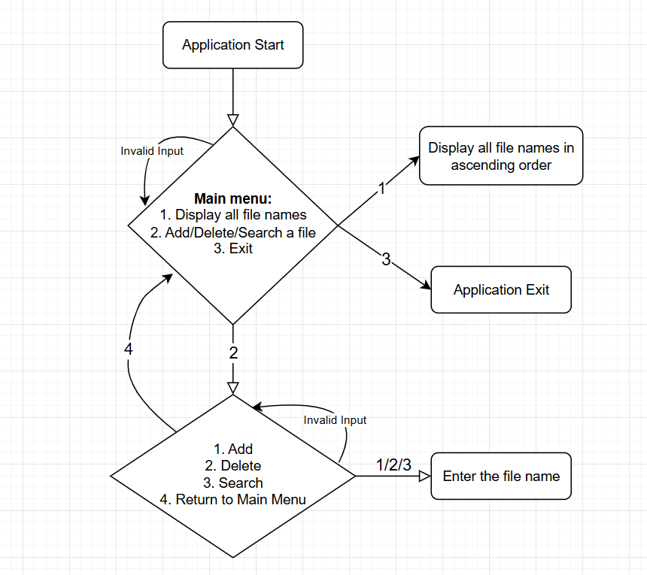

**Fig 1:** Flow of the application

**Core concepts and algorithms used:**

**Concepts:**

1. Classes and objects (methods/attributes)
2. Packages and Access Modifiers
3. Exception Handling
4. File Input/Output
5. Collections
6. Sorting (Inbuilt sort method)
7. Scanners in JAVA

**Algorithms:**

1. JAVA’s inbuild sorting algorithm for display files in ascending order
2. Linear search for searching a file with its filename.

**Exception Handling:**

* FileNotFoundException and IOException used.
* Null/Invalid cases handled separately.

**Conclusion:**

Our application, LockedMe offers a robust but a simple and user friendly way via the command-line to add/search and delete a file. It follows the best up-to-date software development practices along with a proper Git-based workflow.

**USPs:**

* Lightweight and fast Command Line based tool.
* Scalable as it very efficient.
* User friendly with case insensitivity(for adding a file) for ease of use.
* Clear code structure with exception handling.
* Git tracked development and workflows.